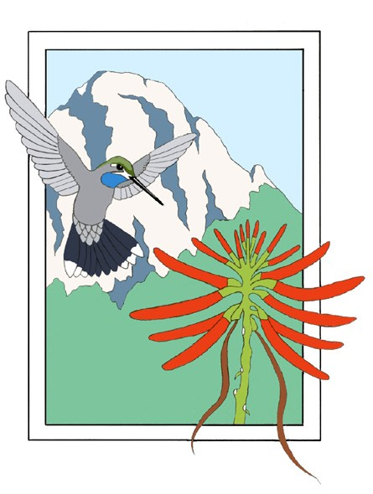***Friends of Madera Canyon***

P.O. Box 1203 Green Valley, AZ 85622-1203

**Application for an Engraved Place on the Honor Wall “In Memory Of”**

The Friends of Madera Canyon is a non-profit organization whose Mission is to “Serve as stewards of Madera Canyon and to keep it open for the enjoyment and education of visitors” through educational and conservation programs. You can become a supporter of the Friends of Madera Canyon by applying for an engraved place on our Honor Wall for a departed loved one: spouse, parent, child, other family member, friend. The Honor Wall is located at the Proctor Accessible Trail entrance site in Madera Canyon.

Requirements for this memorialization in addition to this application are:

* assurance that the loved one is a departed.
* a short letter to the Friends of Madera Canyon describing the reasons why the deceased and/or the donor appreciates and has requested Madera Canyon as a site for this memorialization.
* a payment of $5,000 for the engraving and future maintenance of the Honor Wall.

The single line of engraving is for the name only, not to exceed 20 characters and spaces. The lettering will be 3/4 inches in height and will be etched on the first available space.

**PLEASE PRINT CLEARLY THE NAME OF THE PERSON TO BE MEMORIALIZED IN THE BOXES BELOW.**

Name of Donor:

Address:

City, State, Zip:

Phone: ( ) Email:

Method of Payment: Check made out to the Friends of Madera Canyon, mailed with letter and the application to: Rusty Lombardo, 3381 Placita Del Esconces, Green Valley, AZ 85622. For more information, call Rusty at: (206) 465-5328 or email at: [jim_lombardo@yahoo.](mailto:tfpurdon@cox.net)com

Thank You.

***Conservation through Education***